Placement Report - Percentile

Percentile analysis helps to understand the distribution of data by dividing it into four parts.
The placement data set was analyzed using percentiles.
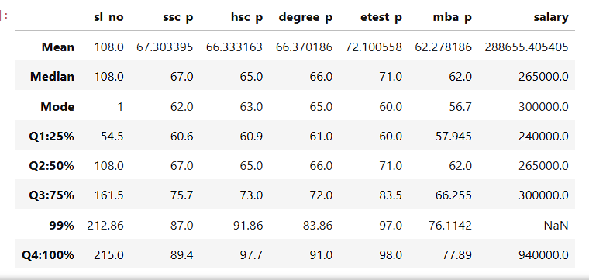

Analysis:

Q1 (25th Percentile)
25% of students scored below:
- 60.6% in SSC
- 60.9% in HSC
- 61% in Degree
- 60% in Entrance Exam
- 57.94% in MBA
The corresponding salary at Q1 is ₹240,000
This indicates that the bottom 25% students received salaries up to ₹2.4 lakhs.

Q2 (50th Percentile / Median)
50% of students scored below:
- 67% in SSC
- 65% in HSC
- 66% in Degree
- 71% in Entrance Exam
- 62% in MBA
The median salary is ₹265,000
This shows that half of the students earned salaries below ₹2.65 lakhs and half earned more.

Q3 (75th Percentile)
75% of students scored below:
- 75.7% in SSC
- 73% in HSC
- 72% in Degree
- 83.5% in Entrance Exam
- 66.25% in MBA
The corresponding salary at Q3 is ₹300,000
This indicates that students in the top 25% performance group generally received salaries up to ₹3 lakhs.

Q4 (100th Percentile / Maximum)
Maximum scores observed:
- 89.4% in SSC
- 97.7% in HSC
- 91% in Degree
- 98% in Entrance Exam
- 77.89% in MBA
Maximum salary offered is ₹940,000
This represents the highest achievers, receiving the highest placement package.

